Chapter 7: Linear Regression

1. **Regression using Scatterplot:**
2. Open the data file (Burger King 1.csv).
3. We can graph the scatterplot by following the steps in Chapter 6.

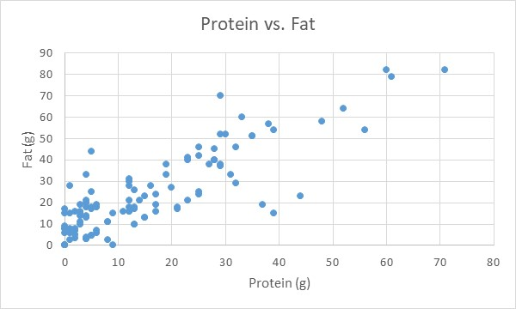

1. Click on the graph, and then select **Design** tab $⟹$**Quick Layout $⟹$** **Layout 9**.

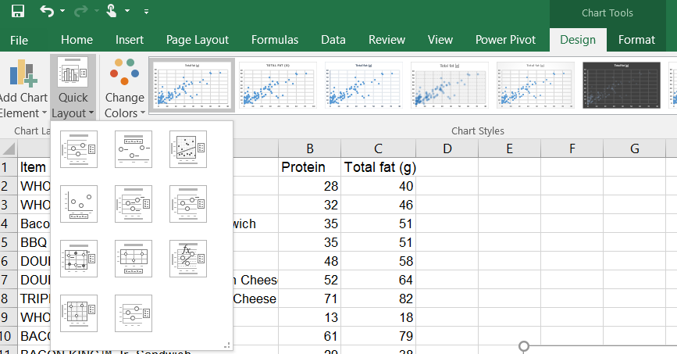

1. The result is

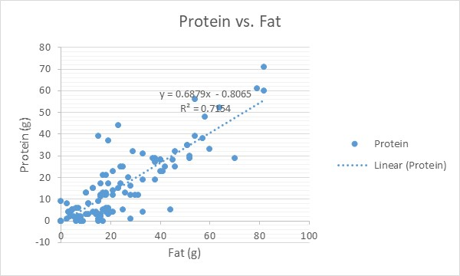

The regression model (equation) is

$$\hat{Protein}=0.6879 Fat-0.8065$$

1. **Regression using Data Analysis:**
2. Select the **Data** tab $⟹$**Data Analysis**.

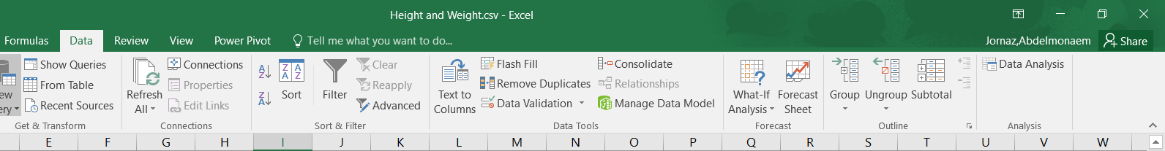

1. The **Data Analysis** box will appear, select **Regression** and click **OK**.

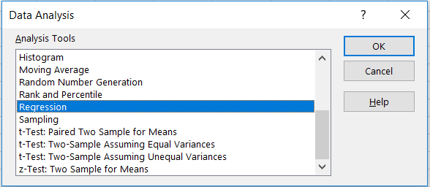

1. The **Regression** box will appear. Click on **Input Y Range** and select range of the dependent variable (protein). Click on **Input X Range** and select range of the independent variable (fat). Select Labels to till Excel that the first row of the data is label. Click on **Output Range** and select any empty cell to present the results on it, then click **OK**.

**Note:** it is very important to set the independent and dependent variable in the right box.

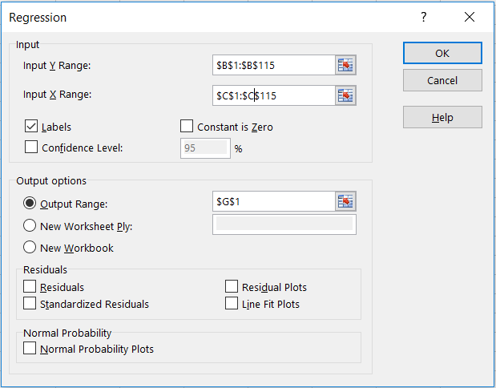

1. The result is

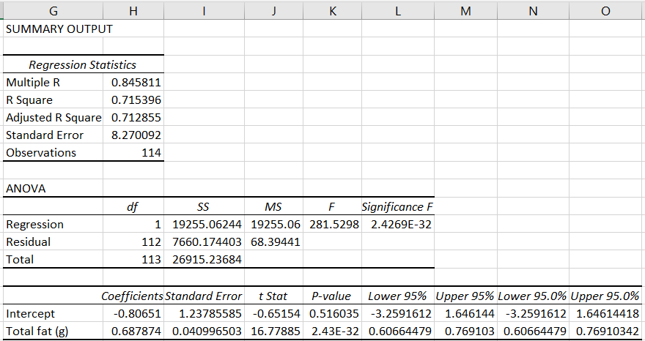

The regression model (equation) is

$$\hat{Protein}=0.6879 Fat-0.8065$$

1. **Regression using Formula:**
2. Select any empty cells, let’s say **G1** and **G2**.
3. Select the **Formulas** tab $⟹$**More Function $⟹$ Statistical $⟹$** **Intercept**.

Select the **Formulas** tab $⟹$**More Function $⟹$ Statistical $⟹$** **Slope.**

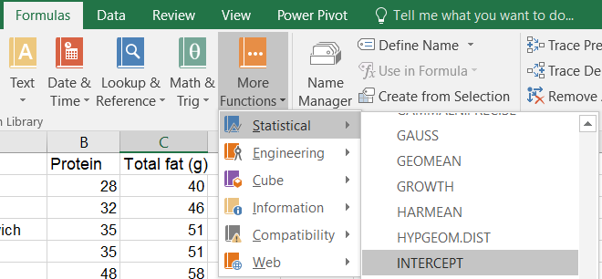

1. The **Function Arguments** box will appear, select the independent variable to **Known_xs** and the dependent variable as **Known_ys**, and then click **OK**.

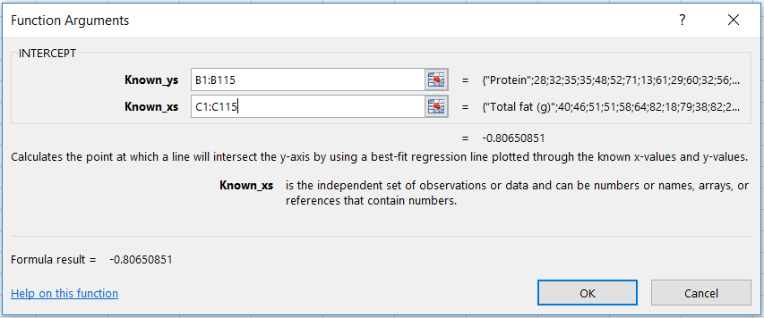

1. The result is

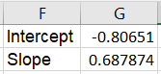

The regression model (equation) is

$$\hat{Protein}=0.6879 Fat-0.8065$$